Advent Prayers with the Church in the Holy Land
This Advent, we are being called to pause from festivities to pray with the church in the Holy Land who are seeking relief from the atrocities of war. Weekly, light a candle for the Holy Land, say a prayer, and consider other ways you may act for a just peace in Israel and Palestine.

Week 1: Hope

What will become of the dream of hope and healing?
In Bethlehem, where there is great sadness and pain?
With the victims of this war and those in dire need who seek relief?

*Candle is lit (moment of silence)*

We wonder and wait for Christ’s hope on this journey.
Although there are no simple answers or easy paths.
May we find the courage to keep on advancing towards God’s dream of justice, peace,
and a love that lasts.

(John Oldham and Alydia Smith, Advent Unwrapped 2023)
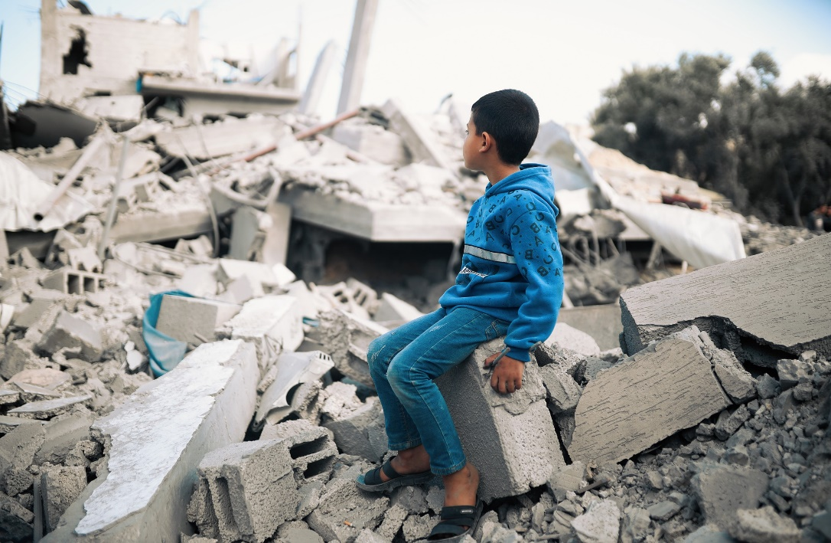
[Photo: DSPR]

Week 2: Peace

What will become of the dream of peace and justice?
In Bethlehem, can peace be reborn?
With those who are living in or fleeing from war?

*Candle is lit (moment of silence)*

We wonder and wait for Christ’s hope on this journey?
Although there are no simple answers or easy paths.
May we find the courage to keep on advancing towards God’s dream of justice, peace,
and a love that lasts.

(John Oldham and Alydia Smith, Advent Unwrapped 2023)

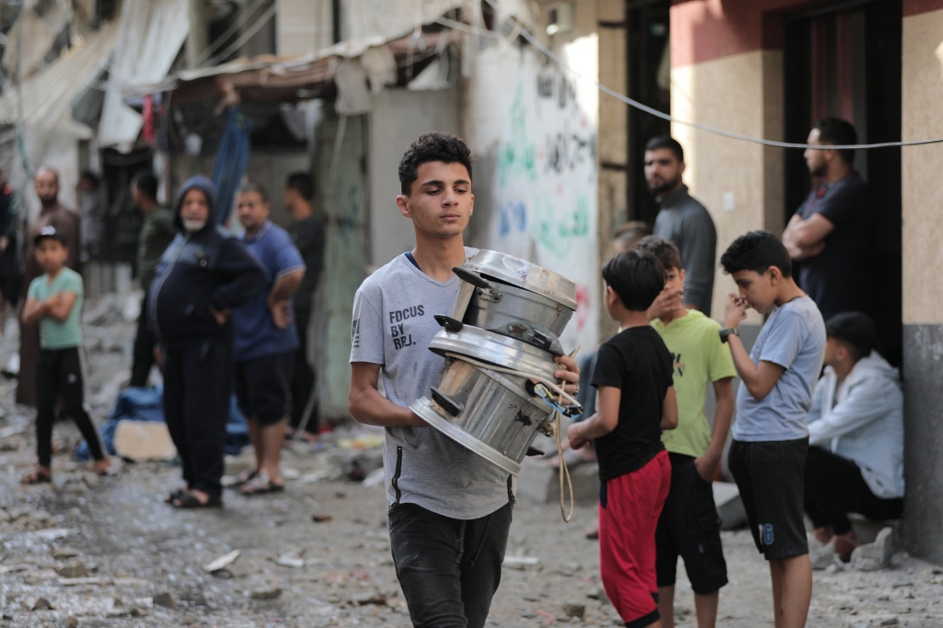
[Photo: DSPR]

Week 3: Joy

What will become of the dream of love and kindness?
In Bethlehem, where there is fear for those in dire need?
With those who are seeking but cannot find humanitarian aid?

*Candle is lit (moment of silence)*

We wonder and wait for Christ’s hope on this journey.
Although there are no simple answers or easy paths.
May we find the courage to keep on advancing towards God’s dream of justice, peace,
and a love that lasts.

(John Oldham and Alydia Smith, Advent Unwrapped 2023)

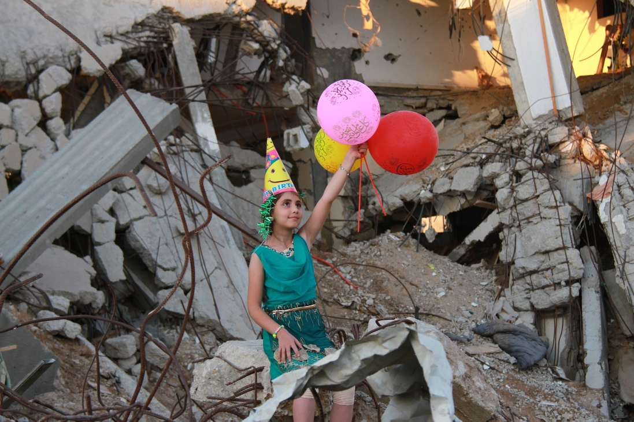
[Photo: DSPR]

Week 4: Love

What will become of the dream of joy and laughter?
In Bethlehem, where young people are crying out in anguish?
With those who are heavily burdened with grief and despair?

*Candle is lit (moment of silence)*

We wonder and wait for Christ’s hope on this journey.
Although there are no simple answers or easy paths.
May we find the courage to keep on advancing towards God’s dream of justice, peace,
and a love that lasts.

(John Oldham and Alydia Smith, Advent Unwrapped 2023)

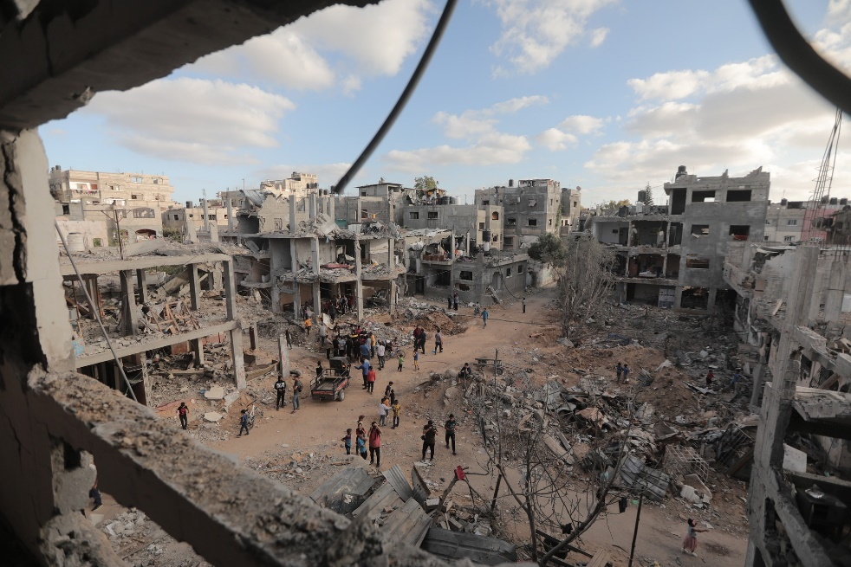
[Photo: DSPR]

